Corey Carter

Professor Rabbi Moshe Plotkin

CPS493-03 Web Server Programming

1/25/24

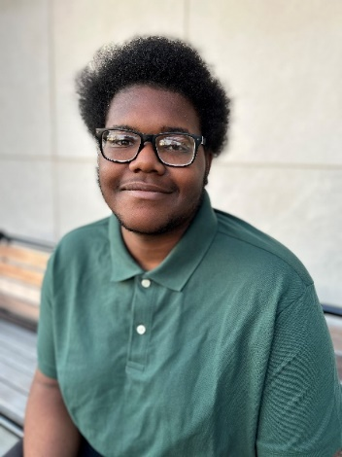

My name is Corey Carter, and I am a Computer Science major with goals to get a Ph.D. in the same field, studying AI (Artificial Intelligence) and/or Cybersecurity. I started learning the field of computer science during a Google coding internship program named Google Code Next. From there, the rest is history, as I have learned many different coding languages such as Java, Python, and more. Some of the projects I have worked on include different websites and robots. For example, I am currently working on a project that combines a scheduler algorithm with an LMS (Learning Management System). I have also collaborated with others on coding projects; however, these projects were for classroom assignments. The computer science classes I have taken so far are Computer Science 1, 2, and 3, Assembly language, and Digital Logic. This semester, I'm taking your class, Language Processing, and Operating Systems.

By taking this course, I see myself improving my coding skills and learning new skills. For example, I have learned SQL; however, MongoDB is the new up-and-coming database management system, so in all, this class is helping me understand that new skill. So, with that, I'm going to take what I learn from this class and apply it to either current projects that I have in mind or future projects or jobs.